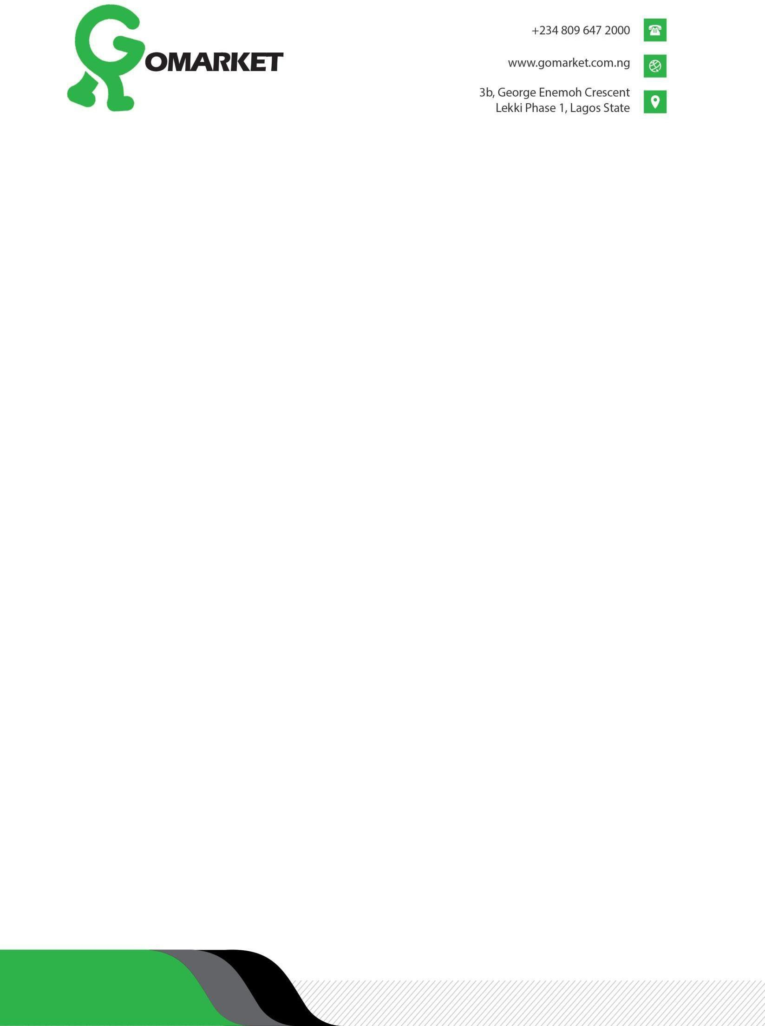

NYSC Lagos State Coordinator, Babs Animashun Street, Surulere Lagos.
29th Dec 2023.

Dear Sir

MONTHLY CLEARANCE FOR DECEMBER 2023

This is to inform you that the corps member Folorunsho Aminat Oluwakemi with state code LA/23A/7083 has carried out her duties and diligently served the establishment for the period up till date. She is hereby cleared for the month of December 2023.

Thank you. Yours Faithfully,
For: Gomarket Limited

Manuel Onuora
(Manager)

